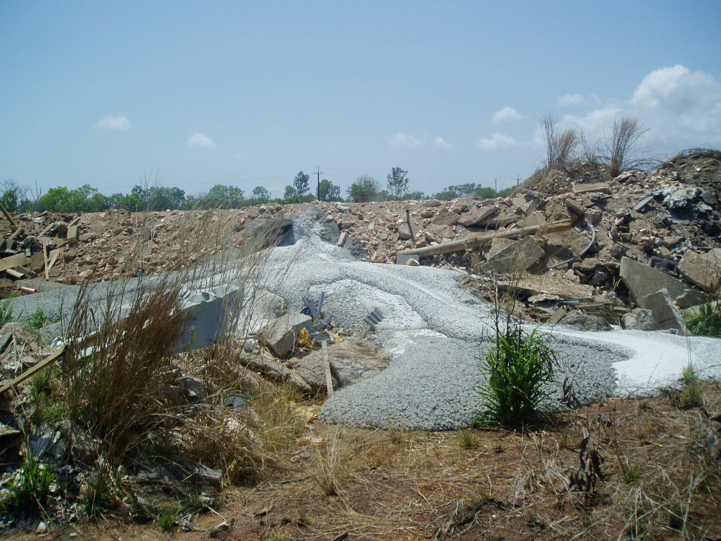
Above and below – Concrete pours dumped in a conservation zone on Kulaluk Lease behind Halikos's illegal stockpile in Ludmilla. Photos by Bill Day and C Tambling taken in about 2013. In response to complaints, Minister Karl Hampton wrote that concrete when dry does not harm the environment.
